ODEON LOGO Page (Technical Whitepaper June 2018) + ODEON Index Page

- Introduction

In the ever-growing world of cryptocurrencies, the market has also evolved into many different directions at several points in time. Miners – and also appliances for cloud-mining contracts – usually have to specify the financial goals they want to pursue, i.e., mainly which coins to mine.
The fixedness of their choices often results in a “What If I’d Chosen Another Currency” when their mined coin dips and since a lot of coins get lost in the shuffle and perish, it seems like a rational idea to make these mining contracts tradeable against each other and currency units, too.
The products of our competition involve such fixed contracts. When customers buy hashpower for a coin that vanishes, they effectively suffer a 100% loss on the rest of their contract.

[ODEON Logo]

ODEON Mining was developed as the solution to the problem of the rapidly growing mining market. We aim to satisfy the needs of the blockchain by providing an integrated multi-altcoin-mining platform being based on a $ 15m ICO.
ODEON aims to provide a platform to equally supply miners and cloud-mining contractees with an intuitive UI that allows easy purchase of said contracts as well as the trading of the same with flexibility and transparency. Whilst users can trade a portion of the contracts (2-year contracts), a second mining contract type expiring after 4 years will also be buyable within the ODEON platform. This one, however, cannot be traded, but therefore offers advantages (i.e., a percentual bonus for loyal customers) over the shorter-lasting one. Also, for the 4-year-contract, the ODE tokens as described in the White Paper will not be lost (i.e., you don’t pay for the contract), but rather be sellable as they were just locked the whole time or can be used for contracting hashpower for another 2 or 4 years, respectively.
The following platforms are already being developed:
- ODEON Mine – starting with 15-25 thousand GPUs and an initial $ 10.5m investment, the capacities are planned to grow to 45-75 thousand GPUs within 3 years.
- ODEON Pool – a mining pool or node network in 2-3 years after Ethereum’s switch to proof-of-stake
- ODEON Gate – a multi-altcoin-cloud-mining contracting platform
- ODEON Trade – a unprecedented platform that allows trading of the Gate contracts
[Image of two contracts on ETH logos with circulating arrows. Somewhat like the following]
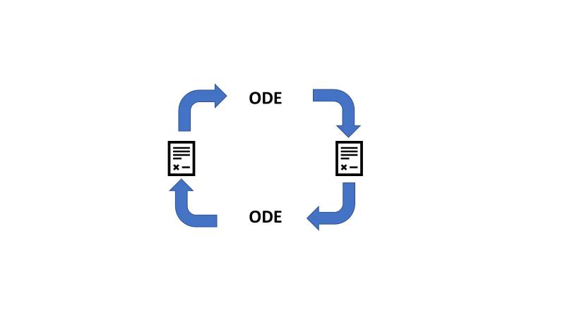

Implementing tradeable contracts offers the possibility to dynamically reallocate ODE tokens either as hashpower (and therefore shares in the total of mined currencies) or as ETH directly to use it for any other purpose. This enables short- as well as long-term-investors to trade better while supporting the network with green energy.

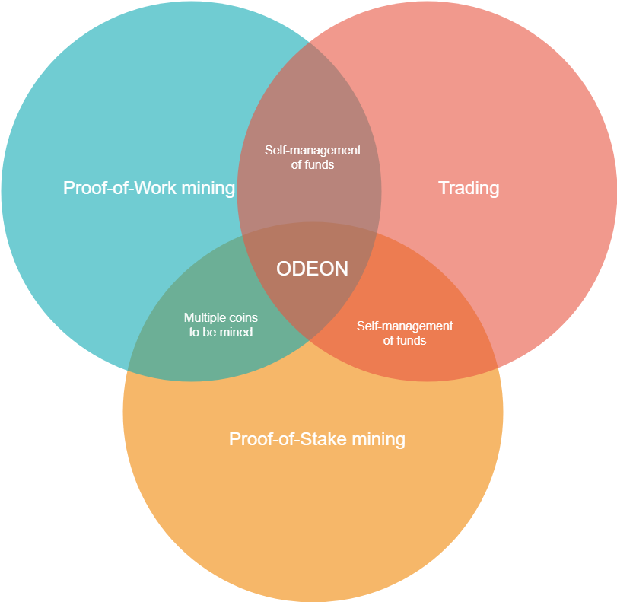

ODEON combines the possibilities of the three main to crypto-investment relevant factors: We offer a multi Altcoin cloud-mining platform that enables the dynamic switch between hash power and currencies.

Our technical paper aims to describe the concepts behind the different systems required to successfully operate a cryptocurrency mining facility. In that course we also aim to describe the concepts of blockchain-security. In addition to that, we also want to demonstrate possible rentability calculations using Black-Scholes-Model.
As a reaction to the upcoming shift from proof-of-work to proof-of-stake of the most desirable cryptocurrency to mine at the moment (i.e., ETH), ODEON wants to develop a platform named ODEON Pool as a proof-of-stake mining-pool when said shift happens (currently estimated to be the end of 2019).

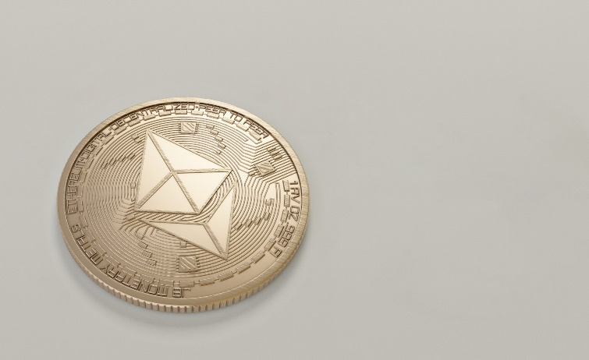

In the following, find more concerning the different platforms we develop as of now.
For the remainder of time using cloud mining, the amount of users that subscribe to this kind of service is expected to grow vastly.

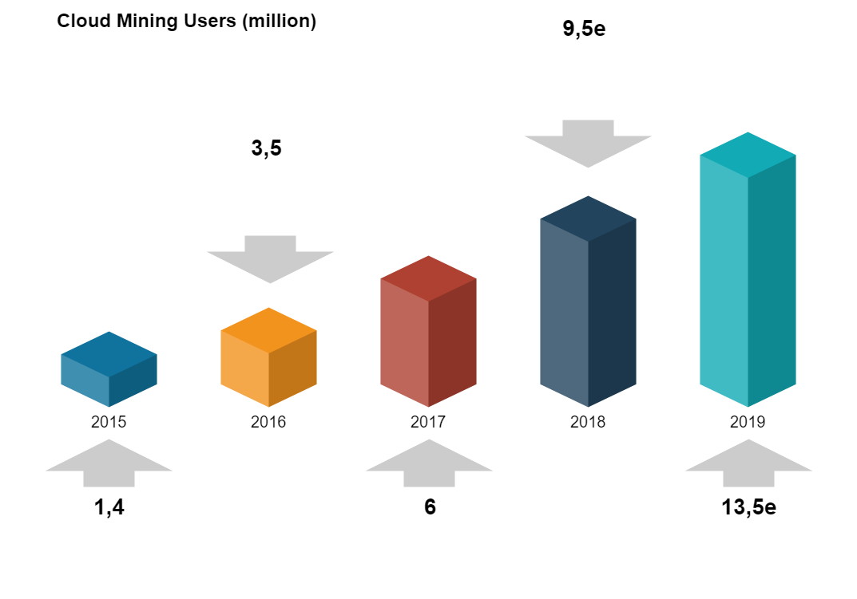

With currently more than 6 million cloud mining users, this number is expected to grow to 9,5m in 2018 and even further in 2019. The only thing holding back the growing is the capability of building mining facilities like ours, mainly limited by the availability of GPUs such as AMD RX 580.
In the following, find our proposed structure for ODEON’s MaaS:

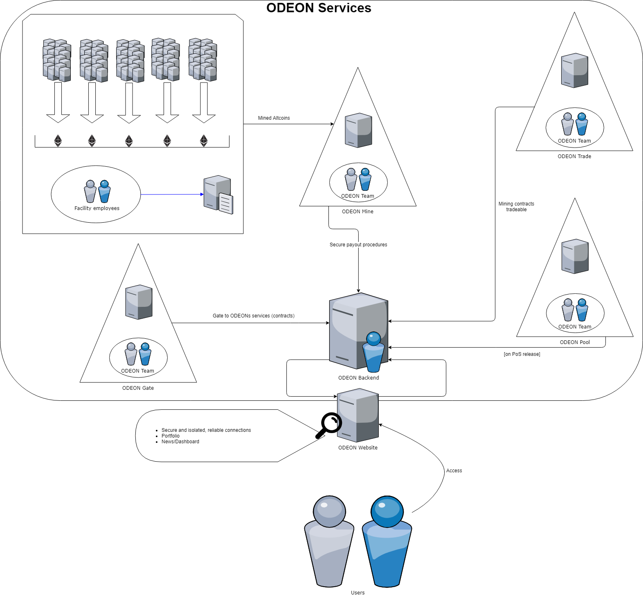

This structure is developed with respect to ensuring a secure and efficient, low-downtime access to servers. Users access ODEONs services through an intuitive web-interface that is connected to the main backend server. This server aims to provide high-security reliable connections to the subservices. Requests will only be transmitted if they are good natured and the first security step will be performed here. The isolated connections to other servers protect the subsystems from malicious requests and outside attacks. The mining facilities will be using even higher security maintained by allocated employees whose main attention will be to provide the described level of security at this single point of highest value creation.

[ODEON MINE LOGO PAGE]

- ODEON Mine Platform
2.1 The platform

With the Mine platform ODEON will operate 1 to 3 mining facilities located in Sweden, Island and Canada. The locations offer green and cheap-as-possible energy to power the graphics cards dedicated to mining. Within this part, we are going to describe some of the technical aspects behind mining (and therefore why there is a need for miners) as well as the financial aspects that follow out of it.

2.2 Mining
In addition to the description of mining in the Whitepaper, which mainly focused on mining in general and the miners point of view. The technical paper focuses more on the mathematical concepts behind mining (such as elliptic curves) and aims to give investors a better understanding of the technology.
In order to ensure that the transaction submitted by the blockchains’s users are not malicious, Satoshi proposed a multistep verification with signatures for each block. Miners therefore set up their hardware (initially CPUs, but GPUs developed to be way faster) for the mere purpose of validating these signatures (and of course to ensure that no one spends money they don’t have).
Different cryptocurrencies use different algorithms to validate blocks. In this technical paper, we are going to describe the process of mining itself and the specialities of the Ethereum hash algorithm (Ethhash). For the following examples and showings, we assume rough knowledge about blockchain-typical keywords.
First off, we need to understand how signatures work. Every address on the blockchain (i.e., every user) has its very own private and public key pair as well as an address. In case of Ethereum, a private key looks like
3a1076bf45ab87712ad64ccb3b10217737f7faacbf2872e88fdd9a537d8fe266

These 42-digits-long address now can be generated with the Keccak-256- hash of the public key and taking the last 40 characters of it, which looks like this
0x7e5f4552091a69125d5dfcb7b8c2659029395bdf
Note that the 0x at the beginning just tells that the following numbers are hexadecimal (0-9 and A,B,C,D,E,F as replacements for 10, 11, …) and it is not part of the Keccak-256 hash.

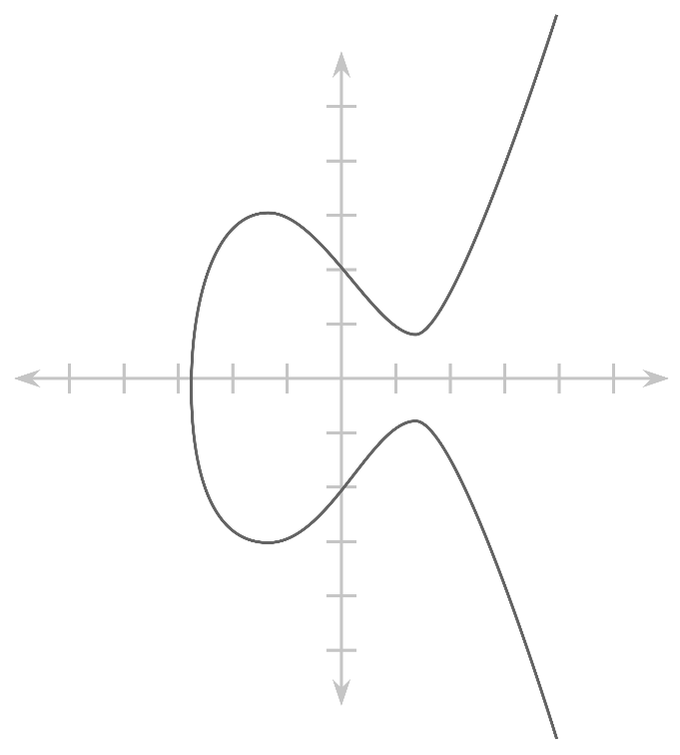
The private key now can be used to sign a transaction and to verify that the sender actually is the owner of the account. The security of the signing relies on elliptical curves.
The general of form of such a curve can be mathematically denoted as
$y^{2}=x^{3}+ax+b$

Consider the following setup:

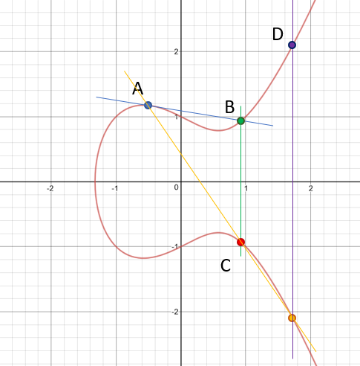
The curve to the left is of the form $y^{2}=x^{3}-x$, meaning we chose a=-1 and b=0.

The point A is the representation of the transaction data and N represents our signing (private) key on the curve.

To follow up on security, elliptical curves are a huge step towards assuring that no one can easily get a private key N from a signature S with known transaction data A.

Now we need to get from the transaction data we want to sign to a correct signature. Elliptical curves as mostly used in cryptocurrencies now use multiplication of A by N, so “data times private key”.

To understand how multiplication (say, 3 x A) works, we need to understand the addition behind it (A+A+A).

For elliptical curve addition, we initially draw a line through two points (usually two different points, for multiplication two times the same) and mirror the intersection to the other side of the x-axis. The resulting point is the sum of the two prior points.
Looking at the graphic, we can get to a multiple of A (for example 2 x A = A+A) by drawing the tangent on the curve at this exact point (“a line through A and A”) and proceeded as described before to get to C=A+A=2 x A. Now we need to repeat this for A and C(=2 x A) to get to D(=3 x A) and so on.
While this might look complicated at first, it’s a rather simple calculation to multiply the data with a private key, but to get from the resulting signature back to the private key is near impossible as there are 2^256 – 1 possibilities for a private key and brute-forcing them is not possible in terms of time and energy required.
Now, having a correctly signed transaction, we can submit it to the Ethereum network and wait for the transaction to be mined and put into a block.

In the next step, the miners validate the correctness of signature. Ethhash comes with a special validation function that takes as input only the signature and the raw transaction data and outputs “TRUE” for a correct signature and “FALSE” for a malicious. The complexity is rather simple. Instead of trying to brute-force a solution, it can be compared to finding prime factors of a large number. Remark: It does not work like prime numbers, this example just demonstrates complexity.
Say, we have the numbers 11 and 7 – both prime. If we communicate their product 77 to other people, they won’t initially know those both primes and have to calculate them. If we now give them one of the two primes, they can just divide the product by it to receive the other prime. Usually these two primes have at least 150 digits each.
Breaking this example down to Ethhash, we have a known prime, the transaction data. we also have the product of these primes, namely the signature. Now we can divide the signature by the transaction data and hopefully get the public key, in which case the signature is valid.

To effectively solve a block – that means putting together multiple transactions and finding a common hash for all of them – miners are required to solve complex mathematical problems. For simplicity, they can be compared to brute-forcing. If a block has, e.g.,10^18 possibilities for the hash to be, and a mining facility delivers a hashpower of 10^12 H/s (=1 TH/s), it would take 1.000.000 seconds or roughly 11d12h to try every single possibility (worst case for finding a single solution). However, these problems leave a certain difficulty underneath the level of finding a single correct hash. We might want to find 1 of 1.000 correct solutions to the problem, leaving an average of 1.000 seconds or 16min40s for a block to be solved.

This validation of signatures as well as the putting-transactions-into-a-block is essentially what mining is all about. However, to not make it easily for malicious people to validate their own fake transactions, the concept of blockchain has a plan to hinder these people: making it expensive to validate.
Whilst the validation is not as hard as brute-forcing, it still takes a lot of calculational power to solve a block. The expense here is the energy required to operate the hardware. The motivation to have a secure payment network is what drives the price up, because without reaching the minimum operational cost as mined ETH, the miners wouldn’t mine.
This is where ODEON chimes in and demonstrates a concept of green yet efficient mining to secure the network and provide investors with participation in doing so by contracting hashpower.

2.3 Potential hardware

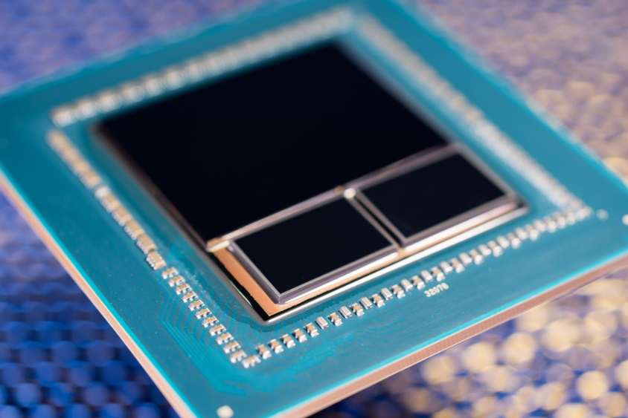
As potential mining GPUs, we decided to choose RX Vega 56 and RX 580 out of the offerings of AMD.
Let’s first dive a little into some of the specs of each graphics card and expand by mining-relevant values.

AMD Radeon RX Vega 56

Process size | 14 nm
Transistors (bn) | 12.5
Core clock (MHz) | 1156
Memory size (MB) | 8192
Avg power draw mining (W) | 190
Ootb ETH-Hashrate (MH/s) | 31.0
MH/s per Watt | 0.16

AMD RX 580

Process size | 14 nm
Transistors (bn) | 5.7
Core clock (MHz) | 1411
Memory size (MB) | 8192
Avg power draw mining (W) | 175
Ootb ETH-Hashrate (MH/s) | 25.0
MH/s per Watt | 0.14

Notably, these are the optimized numbers we found tweaking the graphics cards. Most optimizations made it possible to increase the megahashes per Watt by 20-30% (23% at average).
Considering the most relevant number in terms of profit (MH/s per Watt), the RX 580 is more profitable to mine with over a long duration. However, the lack of availability of the GPU makes it hard to gather enough RX 580s for a single fully functional mining facility in our design (25.000 GPUs). RX Vega 56s are available in greater numbers as we could barely order any RX 580s at the moment. A big role in the choice of RX 580 and RX Vega 56 also was the selling price in many years in relation to the buying price now. As described more precisely in the White Paper, the comparison of multiple graphics cards yielded the highest revenue for customers with these two.
Depending on their availability, we plan to build up to three facilities, each with 15.000 RX Vega 56s or with 25.000 RX 580s.

2.4 Financial aspects
The energy cost per day was calculated as follows:
Cost_{($/day)} = E_{(kWh/day)} × Cost_{(cent/kWh)} / 100_{(cent/$)}

Currently, we can obtain power in our planned mining facilities for less than 5ct/kWh. The calculations from the Whitepaper still hold true:

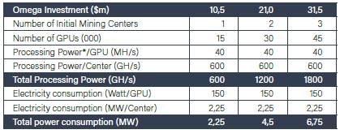
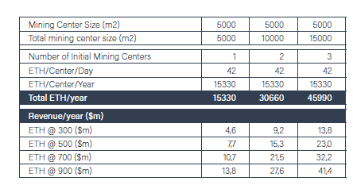
Cost per day was calculated as follows
Cost_{($/day)} = E_{(kWh/day)} × Cost_{(cent/kWh)} / 100_{(cent/$)}

Based upon the graphics cards we chose and the amount of these we want to operate, each of the mining centers will, as denoted in above figure, consume 2,25MW of energy while generating more than 15.000ETH per year. Considering energy considerations of around 5ct/kWh, ODEON needs to spend more than a hundred thousand dollars (112.500$) per year yet alone for electricity. The projected revenue is - even for a low ETH-price – well in the millions. A single GPU is estimated to generate $ 2,10 per day, which means that 15.000 will generate roughly $ 31.500 per day or $ 11,5m in a single year.
More precise financial calculations can be found in the Whitepaper released shortly before.

[ODEON POOL LOGO]

- ODEON Pool
4.1 Casper

4.1.1 What is Casper?

As announced the Ethereum-Network will change it’s mining technique from proof-of-work (PoW) to proof-of-stake (PoS). Unlike the proof-of-work, where the miner gets a reward for validating and creating blocks, with PoS you won’t create new blocks and won’t have to validate the blocks with big calculations.

One of the biggest benefits of PoS is the reduction of high electricity costs for validating-calculations. It is estimated that Bitcoin and Ethereum cost more than 1 million dollars in electricity and hardware costs per day. Besides that, the PoS algorithm reduces centralization and makes 51& attacks more difficult.
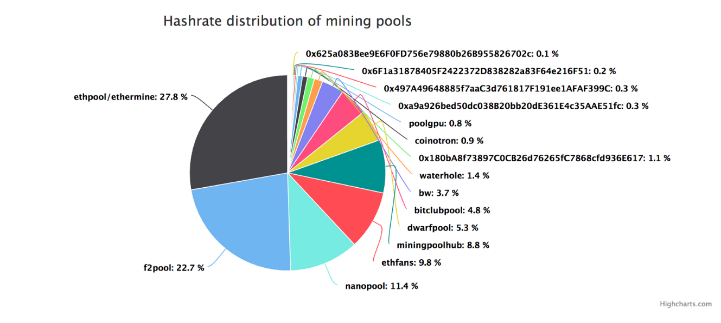
(Source: https://cryptovest.com/news/ricardian-contracts-inventor-says-dpos-more-decentralized-than-ethereum-and-bitcoin-mining/ - 31.05.2018)

As you can see, 5 different mining pools alone have over 70% of the full mining power. This opens up the unlikely possibility of a so-called 51 percent attack. Mining pools, which provide more than 50 percent of the computing power, could endanger the security and stability of the network. In contrast to PoW, it is not computing power but assets that are used as protection against manipulation. An attacker must have more than half of the total ability to lead a valid parallel chain with sufficient probability.

In August of 2017, Vitalik Buterin released an implementation guide for Casper v1. This version is a hybrid of proof-of-work and proof-of-stake. The first version of Casper will use the proof-of-stake consensus only at every hundredth block – called checkpoints. At least two third of the active validators in the pool are needed to finalize these blocks. Afterwards it is not possible to use a chain without these checkpoints. Even if 99% of miners start supporting a chain that does not contain that block, all clients in the network will still use the chain with the finalized block. This removes a lot of decision power of the miners.

4.1.2 Minor changes with casper v1

Casper v1 will decrease the profitability for each miner from 3 ETH block reward to 0.6 ETH and every 100th block soon being validated by PoS. In case of that ODEON Mining is switching to the current most profitable coin to keep the best profit. This could be Monero or Ethereum Classic.

 | Ethereum (ETH) | Monero (XMR) | ETH Classic (ETC)
Block reward (static)*¹ | 3 ETH | 4,50 XMR | 4 ETC
Difficulty | 3.225 P | 50.912 G | 120.35 T
Network hashrate | 272.033 TH/s | 431.338 MH/s | 9.093 TH/s
Rentability | 0,0463 USD $ / day (1 MH/s) | 1,2215 USD $ / day (1kH/s) | 0,0425 USD $ /day (1 MH/s)

*¹ : to each static block reward the miner gets a small amount of transaction fees. In case of ETH and ETC there is in addition a little amount of uncles reward.

(Source: bitinfocharts.com - 31.05.2018)

Hash rate calculations:
1 kH/s | 1.000 hashes per second
1 MH/s | 1.000 kH/s | 1.000.000 hashes per second
1 GH/s | 1.000 MH/s | 1.000.000 kH/s
1 TH/s | 1.000 GH/s | 1.000.000 MH/s

4.1.2 Release Casper v1

The estimated date for the implementation of Casper v1 is the Hard Fork called Constantinople which will probably be on Q4/2018. Since the moment when Ethereum network will switch complete to PoS consenus (Serenity Release) ODEON Pool is going live.

Ethereum Roadmap:

4.2 Pool
„It's actually ~1000 initially, unless you want to join a stake pool. Numbers closer to 10 will become possible when we do sharding“ (Vitalik Buterin)

(Source: https://www.reddit.com/r/ethereum/comments/6tj5d0/any_updates_on_ethereums_pos/ - 14.08.2017 )

With ODEON Pool it is not necessary to think about the number of ETH. In our Ethereum ODEON Stake Pool you gain the validation reward however your amount for participation is too low.

    - Participation Example

A little calculation how this will work:

- 10 ETH are the minimum requirement for the staking pool.
- ODEON Pool user deposit 2.75 ETH.

10 ETH / 100 * 2.75 ETH = 0.275 = 27.5 %

The payout of your proof of stake participation would be 27.5% of the total earned ETH for PoS – validation. In an abstract form:

MPA / 100 * OPD = ER (%)

MPA := Minimum Pool Amount
OPI := ODEON Pool Deposit
ER := Earning Rate in percent

The basic idea of the PoS is to decouple a miner's voting power from his computing power towards weighting it according to the number of coins in his possession. Only the rich get richer? This is one of the most criticized points of the Proof of Stake algorithm. Unfortunately, as already mentioned, you now get a reward for your assets in the respective virtual currency in proportion to your total assets. This means that the more you have in this currency, the greater the payout. We from ODEON can‘t change the system, but we are able to give you the possibility for participation!

    - Estimated Revenue

“Currently, an expected value is 10 million ETH staking at 5% interest, which is 500,000 ETH per year (~0.22 ETH per block).” (Vitalik Buterin)

At the moment there are no exact values, so this can only be speculated. The block rewards will be reduced to 0.22 ETH at the beginning of PoS. According to Vitalik Buterin's quotation, approximately 5 percent revenue per year are still to be expected.

[ODEON Gate]

- ODEON Gate
Users can purchase cloud mining contracts via a web platform. These so-called ODEON Gate contracts run for 24 months and can only be purchased with ODE tokens. The ODEON Gate contract will be tradeable on the ODEON Trade platform.
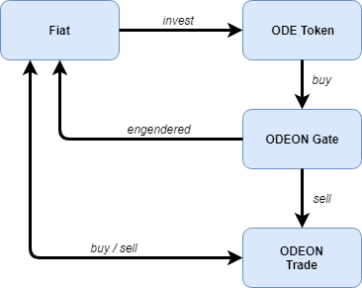

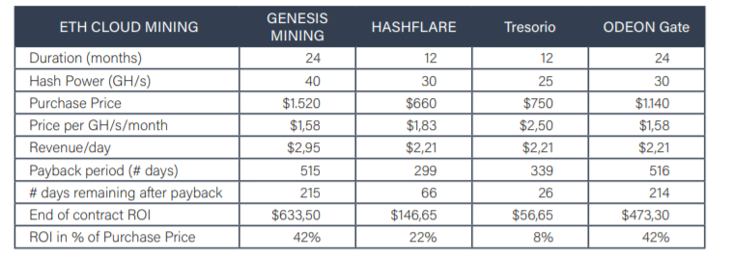
Comparison to other providers:
In terms of profitability ODEON Gate will be competitive with Genesis Mining offerings. It should be noted that in early April 2018 most cloud mining contracts are not profitable given the crypto currency price decline during the last 4 months. Should that situation persist, even if mining the most profitable Altcoin provides no better alternative, ODEON Gate will not propose cloud mining contracts and will rather proceed with auto-mining in ODEON Mine centers.

